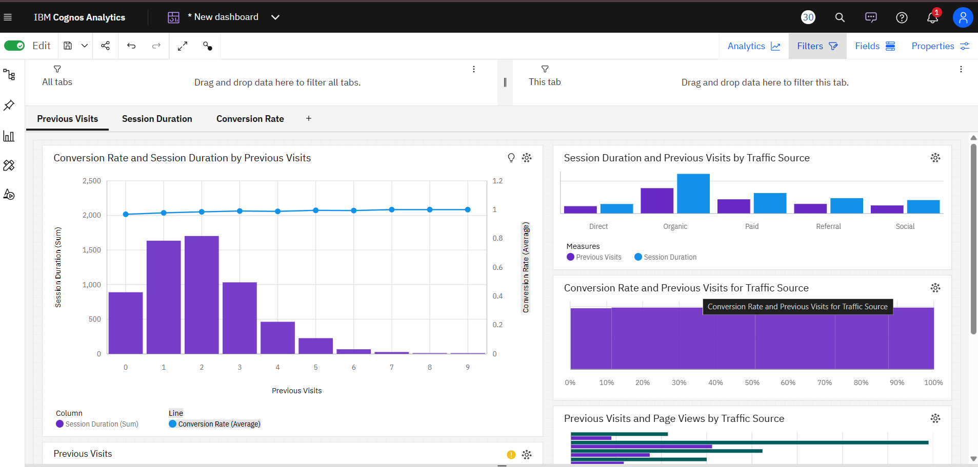

Description:

The screenshot shows a dashboard in IBM Cognos Analytics with multiple data visualizations related to Previous Visits, Session Duration, and Conversion Rate.

Here’s a detailed description of the image:

* Header Section (Top Bar):
  + The title bar shows IBM Cognos Analytics.
  + Options include Edit, Share, Undo, Redo, Refresh, Analytics, Filters, Fields, Properties, and user account icons.
  + The dashboard is currently in Edit mode.
* Dashboard Tabs:
  + Tabs available: Previous Visits, Session Duration, Conversion Rate.
  + The displayed tab is Previous Visits.
* Main Visualizations (Left to Right, Top to Bottom):
  + Chart 1 (Large Left Chart)
    - Title: *Conversion Rate and Session Duration by Previous Visits*.
    - Type: Combination chart (Bar + Line).
    - Purple bars represent *Session Duration (Sum)*.
    - Blue line represents *Conversion Rate (Average)*.
    - X-axis: Previous Visits (0–9).
    - Y-axis (Left): Session Duration (Sum).
    - Y-axis (Right): Conversion Rate (Average).
  + Chart 2 (Top Right)
    - Title: *Session Duration and Previous Visits by Traffic Source*.
    - Type: Grouped bar chart.
    - Categories: Direct, Organic, Paid, Referral, Social.
    - Purple = Previous Visits, Blue = Session Duration.
  + Chart 3 (Middle Right)
    - Title: *Conversion Rate and Previous Visits for Traffic Source*.
    - Type: Bar chart.
    - X-axis: Conversion percentage (0%–100%).
    - Purple bars indicate relationship between Conversion Rate and Previous Visits.
  + Chart 4 (Bottom Right)
    - Title: *Previous Visits and Page Views by Traffic Source*.
    - Type: Horizontal bar chart.
    - Shows comparison of Page Views (teal) and Previous Visits (purple) across traffic sources.
* Bottom Toolbar (Windows Taskbar):
  + Windows 11 taskbar visible with icons like Edge, File Explorer, Outlook, Teams, WhatsApp, and system tray.
  + Time: 11:50 AM.
  + Date: 8/6/2025 (August 6, 2025).
  + Language: ENG (IN).

Overall, the dashboard is analyzing user behavior data—how previous visits, traffic sources, and session duration affect conversion rates and engagement metrics.